Sean Levorse

ENGL 361-03

How to Solve a Standard Rubik’s Cube

**Introduction:**

Since 1980, the Rubik’s cube has been puzzling people of all ages. However, there is a method that vastly simplifies the process of restoring all of the colors to their correct places. The first thing that you need to understand in order to solve the cube is that the puzzle consists of 20 plastic pieces rotating around one fixed core:

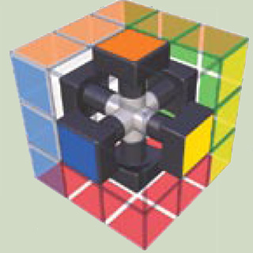

<http://s1.thingpic.com/images/EN/LGxnD8tBSGAnQLxrd9A2.jpeg>

These pieces can either be an edge piece with only two colors on it or a corner piece with three. These piece rotate around the center as if the centers don’t move.

When solving the cube, you need to think of it as a 3 dimensional puzzle, not a set of six 2 dimensional faces. For this guide, I will be using standard algorithms, or codified instructions on what order and direction necessary to solve the puzzle. These algorithms will be demonstrated as a series of letters and apostrophes, for instance RUR’U’. The letters correspond to a 90 degree clockwise rotation around that face: F for front, B for back, R for right, L for left, U for upper, and L for lower:

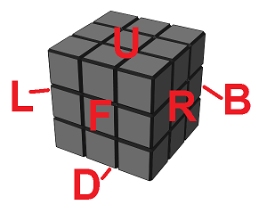

<http://w.astro.berkeley.edu/~converse/images/rubiks/faces.png>

An apostrophe represents a 90 degree counter clockwise rotation. So RUR’U’ would be a clockwise turn of the right face, a clockwise turn of the upper face, a counterclockwise turn of the right face and a counterclockwise turn of the upper face in that order. Note that a clockwise turn of once face moves in the opposite direction as a clockwise turn from the face on the other side of the cube. Turning the right face clockwise moves the top pieces away from you while turning the left side clockwise moves the top pieces toward you. If you find the algorithm doesn’t do what it’s supposed to do, you may need to start over. Take a deep breath and pay close attention to what you are doing. The first time you do it, it may take an hour to get the algorithm’s down, but over time, with a bit of practice, you can be able to solve a rubik’s cube in about a minute! The best part is you can practice anywhere and it will look impressive to the people around you.

**Materials:**

1. A 3x3x3 twisty puzzle, often called a rubik’s cube
2. Patience

**Steps:**

1. The Cross:

This step is the only step that there is no algorithm for. Pick a center and move the four edges with that color on it to their proper places. This should make a cross of that color on that face. Make sure that the edges also align with the proper centers on the middle layer. It should look something like this:

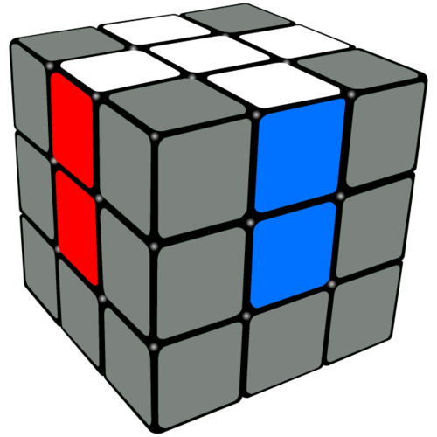

<http://static1.squarespace.com/static/54f2df67e4b079e94c291e4f/t/55150cb5e4b0413cd5dfbe67/1427442870792/cross+done+u+cross.png?format=500w>

1. The Top Face:

The next step is the move the corners for the top layer into place. Look for any corner piece that has the color of the cross on it. You will want to position it so that it is in the bottom layer between the two other colors on it. For example in the image above, you would want to position the red/white/blue corner in the front, right, bottom corner:

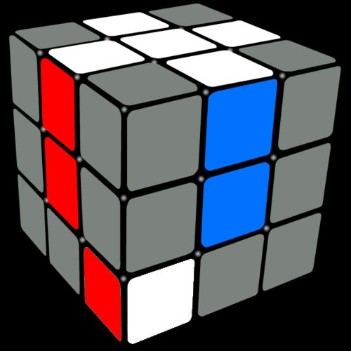

Created by me in GIMP

From here, you can use the algorithm R’ D’ R D up to 5 times until it is in the correct spot and rotation. It shouldn’t take more than 5 repetitions. This algorithm switches the corners between the top and bottom layers as well as rotation them. So if a corner is in the wrong place, but still in the top layer, you can use it to move it to the bottom layer and put it in the correct place. After this step is complete, it should look like this:

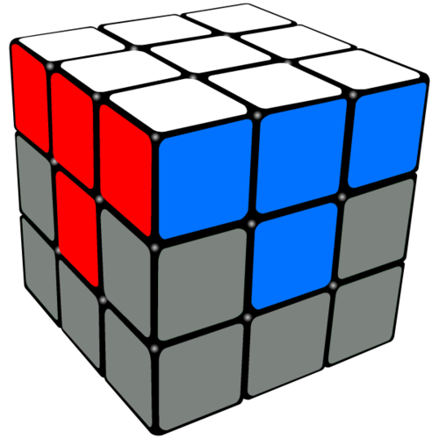

<http://static1.squarespace.com/static/54f2df67e4b079e94c291e4f/t/55150cc7e4b0413cd5dfbe7e/1427442888966/step3_rubiks_cube?format=500w>

1. The Middle Layer:

Flip the cube over. The next step is to move the edge pieces for the middle layer into their respective places and orientations. To do this you need two algorithms that are the mirror of each other:

U R U’ R’ F’ U F

Or

U’ F’ U F R U’ R’

The first algorithm switches these two pieces:

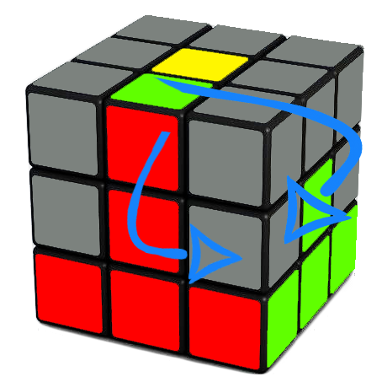

<http://static1.squarespace.com/static/54f2df67e4b079e94c291e4f/t/562c97cfe4b0be3275fc622f/1445763027298/rubiks+cube+edge+insert+right?format=500w>

And the second algorithm switches these two pieces:

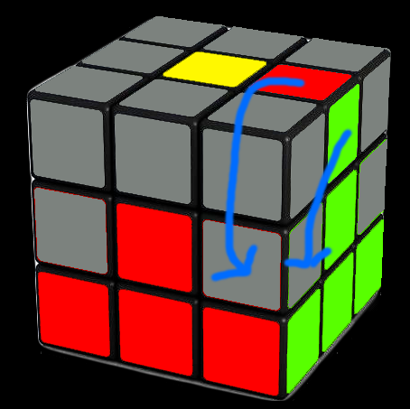

Created by me with GIMP

The goal is to align the edges like you see in the pictures by turning the top layer and using the given algorithm to put the edge pieces into the middle layer in the correct orientation. If an edge is already in the middle layer, or is in backwards, you can use either of these algorithms to move it back to the top layer before putting it in the correct place again.

In the end, the cube should look like this:

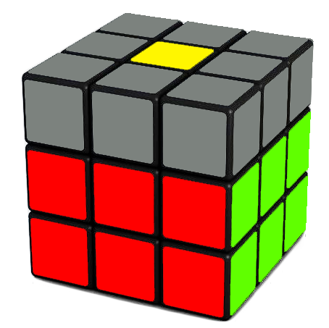

<http://static1.squarespace.com/static/54f2df67e4b079e94c291e4f/t/562c97c0e4b0e2b30b09b81c/1445763012254/rubiks+cube+two+layers+done?format=500w>

1. The Top Cross:

Next, look at the top and see if the edge pieces are facing the right direction. They don’t need to be in the correct places, they just have to be facing up to make another cross. The algorithm for this step is:

F R U R’ U’ F’

If the cube looks like this:

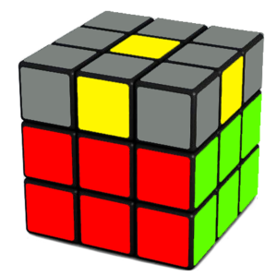

<http://static1.squarespace.com/static/54f2df67e4b079e94c291e4f/t/562c991be4b0b7066cfa5214/1445763358763/rubiks+cube+yellow+dot?format=300w>

Do the algorithm 3 times.

If the cube looks like this:

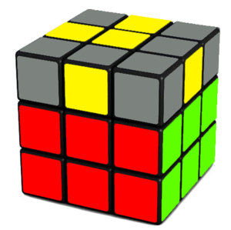

<http://static1.squarespace.com/static/54f2df67e4b079e94c291e4f/t/562c9926e4b032ea4e3eeb80/1445763372787/rubiks+cube+yellow+L?format=300w>

Do it twice. And if the cube looks like this:

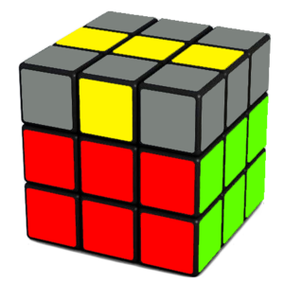

<http://static1.squarespace.com/static/54f2df67e4b079e94c291e4f/t/562c9934e4b032ea4e3eeb99/1445763384719/rubiks+cube+yellow+line?format=300w>

Do it once.

In the end, the cube should look like this:

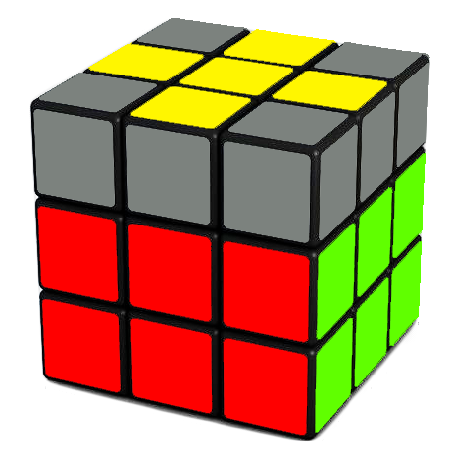

<http://static1.squarespace.com/static/54f2df67e4b079e94c291e4f/t/562c990ee4b0b7066cfa51fd/1445763346097/rubiks+cube+yellow+cross?format=500w>

1. The Top Cross part 2:

The next step is to put the edges in their correct places. Rotate the top layer until either one or two of the edges are on the correct face. If there is one edge, rotate the cube so that that face is the “Front” face and do this algorithm:

R U R’ U R U U R’

If there are two pieces on their correct faces, rotate the cube until one of the correct faces is on the “right” face and one is on the “back” face and do R U R’ U R U U R’ U

The cube should look like this at the end of this step: 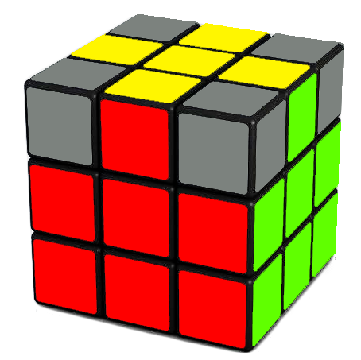

<http://static1.squarespace.com/static/54f2df67e4b079e94c291e4f/t/562c9e0be4b057e30c6bcd33/1445764623761/rubiks+cube+yellow+cross+done?format=500w>

1. Move the corners to the correct places:

The algorithm for this step is:

U R U’ L’ U R’ U’ L

Look at the colors on each corner. Count how many corners are in the correct location. They may be rotated in the wrong direction, as long as the colors on the corner match the faces it is a part of. If there are no corners in the right place, do the algorithm once and one should move into the correct place. If there is one corner in the correct place, rotate the cube so that it is the front right top corner like this:

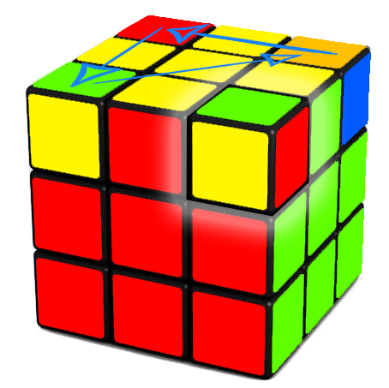

<http://static1.squarespace.com/static/54f2df67e4b079e94c291e4f/t/562ca011e4b079eaf38c4db2/1445765141510/rubiks+cube+corner+permutation?format=500w>

If all of the corners are in their correct locations, you can skip this step.

1. Rotate the Top Corners:

This last step is the most complicated. You use the same algorithm from step 2:

R’ D’ R D

However, doing this algorithm on each corner will mess up the cube. Instead, what you have to do is pick one corner and run the algorithm until it is rotated correctly, that is the top color is facing up. Then rotate the top layer so that the next corner that needs to be rotated replaces that corner and run the algorithm again until it is rotated. Rinse and repeat until the corners are all oriented correctly and fix the top layer and your cube should be solved.

If you mess up at any of the points during these steps, it’s okay. It’s pretty common when you are first learning to solve the cube. Take a deep breath and see if you can undo the steps that you just did. If not, you may need to restart a step, or start from the beginning again. After enough repetition, the algorithms will become familiar and you will start to recognize which algorithms to use when and find shortcuts for certain scenarios. Then the next challenge is the 4x4x4! Good luck and happy cubing.

**Glossary:**

Algorithm – A sequence of moves used to switch and rotate specific pieces.

Center – The piece in the center of a face that only has one color and can only spin. It does not move relative to the other centers.

Corner – A piece with three colors between three edges.

Edge – A piece with two colors on it between two centers.

Face – The 9 stickers that make up one side of the cube.

Location/Position – Where a piece is in relation to the centers. Edges can be in one of twelve locations while corners can be in one of eight locations.

Orientation – The order of stickers on a piece. Edges have two orientations while corners have three.